Raspberry Pi Wheelchair With Safety System
Here we propose raspberry pi based wheelchair with safety features. The system utilizes raspberry pi along with graphic LCD display, rf technology and motorized circuit in order to achieve this system. Our proposed system consists of a controller circuit and a wheelchair circuit. The controller circuit allows the user to provide direction commands to the wheelchair through a directional graphical LCD display. The wheelchair circuit consists of a rf receiver used to receive these commands and then operate the wheelchair motors in order to achieve desired movement. This allows the disabled person th operate the wheelchair easily as well as another person can operate the wheelchair from 3-4 meters distance. Also the system consists of emergency help features for the disabled. If the person is in trouble or needs help the person just needs to press a button and his gps coordinates are sent to his/her loved ones through sms message. Also if the person falls from wheelchair or is unable to press the button, he/she just needs to shout help and the system automatically sends the GPS coordinates through sms message to persons loved ones.

Block Diagram:
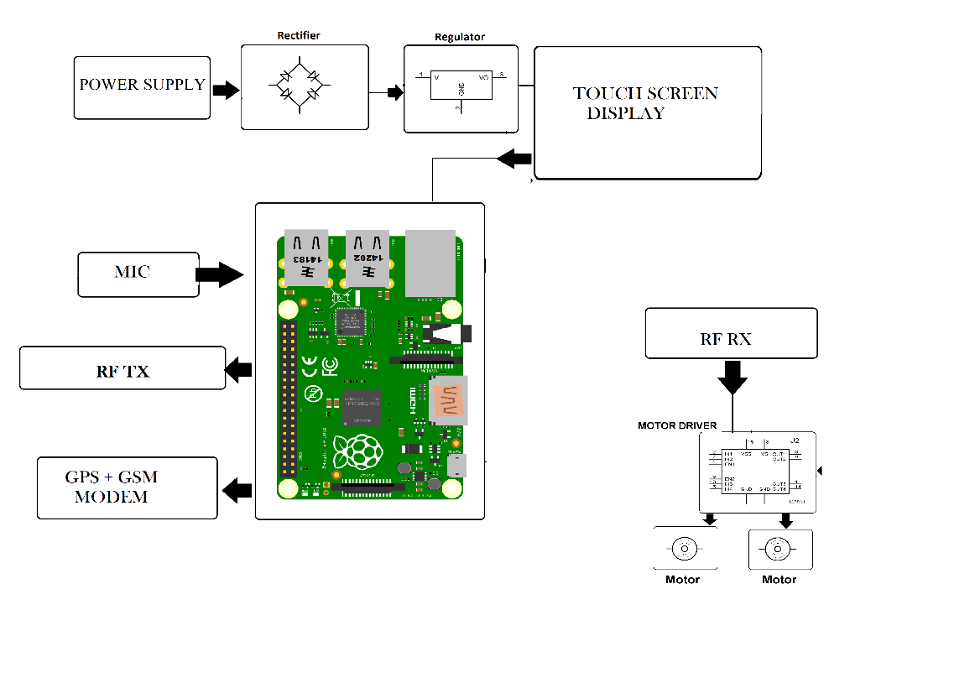
Hardware Specifications
- Power Supply
- Rectifier
- Regulator
- Touch Screen Display
- MIC
- GPS Module
- GSM Modem
- Raspberry Pi
- Motor
- Rf Transmitter
- Rf Receiver
- Resistors
- Capacitors
- Diodes

Software Specifications
- Python 3 compiler
- Programming Language: Python

